The Contrails app is an Android App that allows the user to take a picture of clouds in the sky to determine whether or not the cloud is a "cloud" or a contrail left behind by an aircraft.

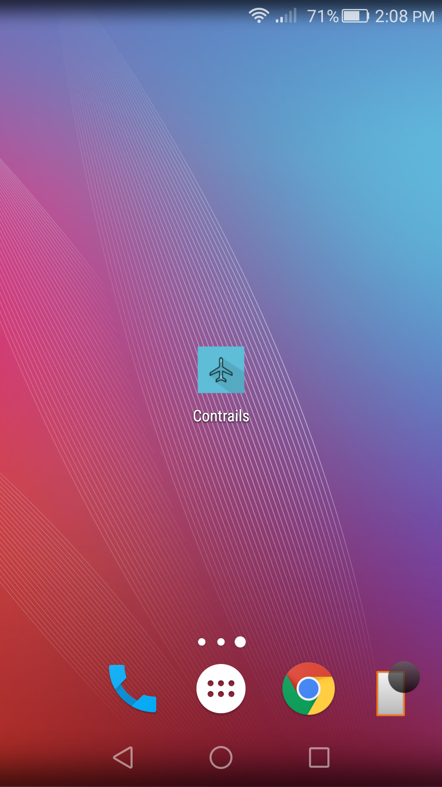

The user interaction with the app is fairly simple. As soon as the user launches the app, he/she is presented with a screen that asks the user to take a picture of the clould that he/she is interested in.

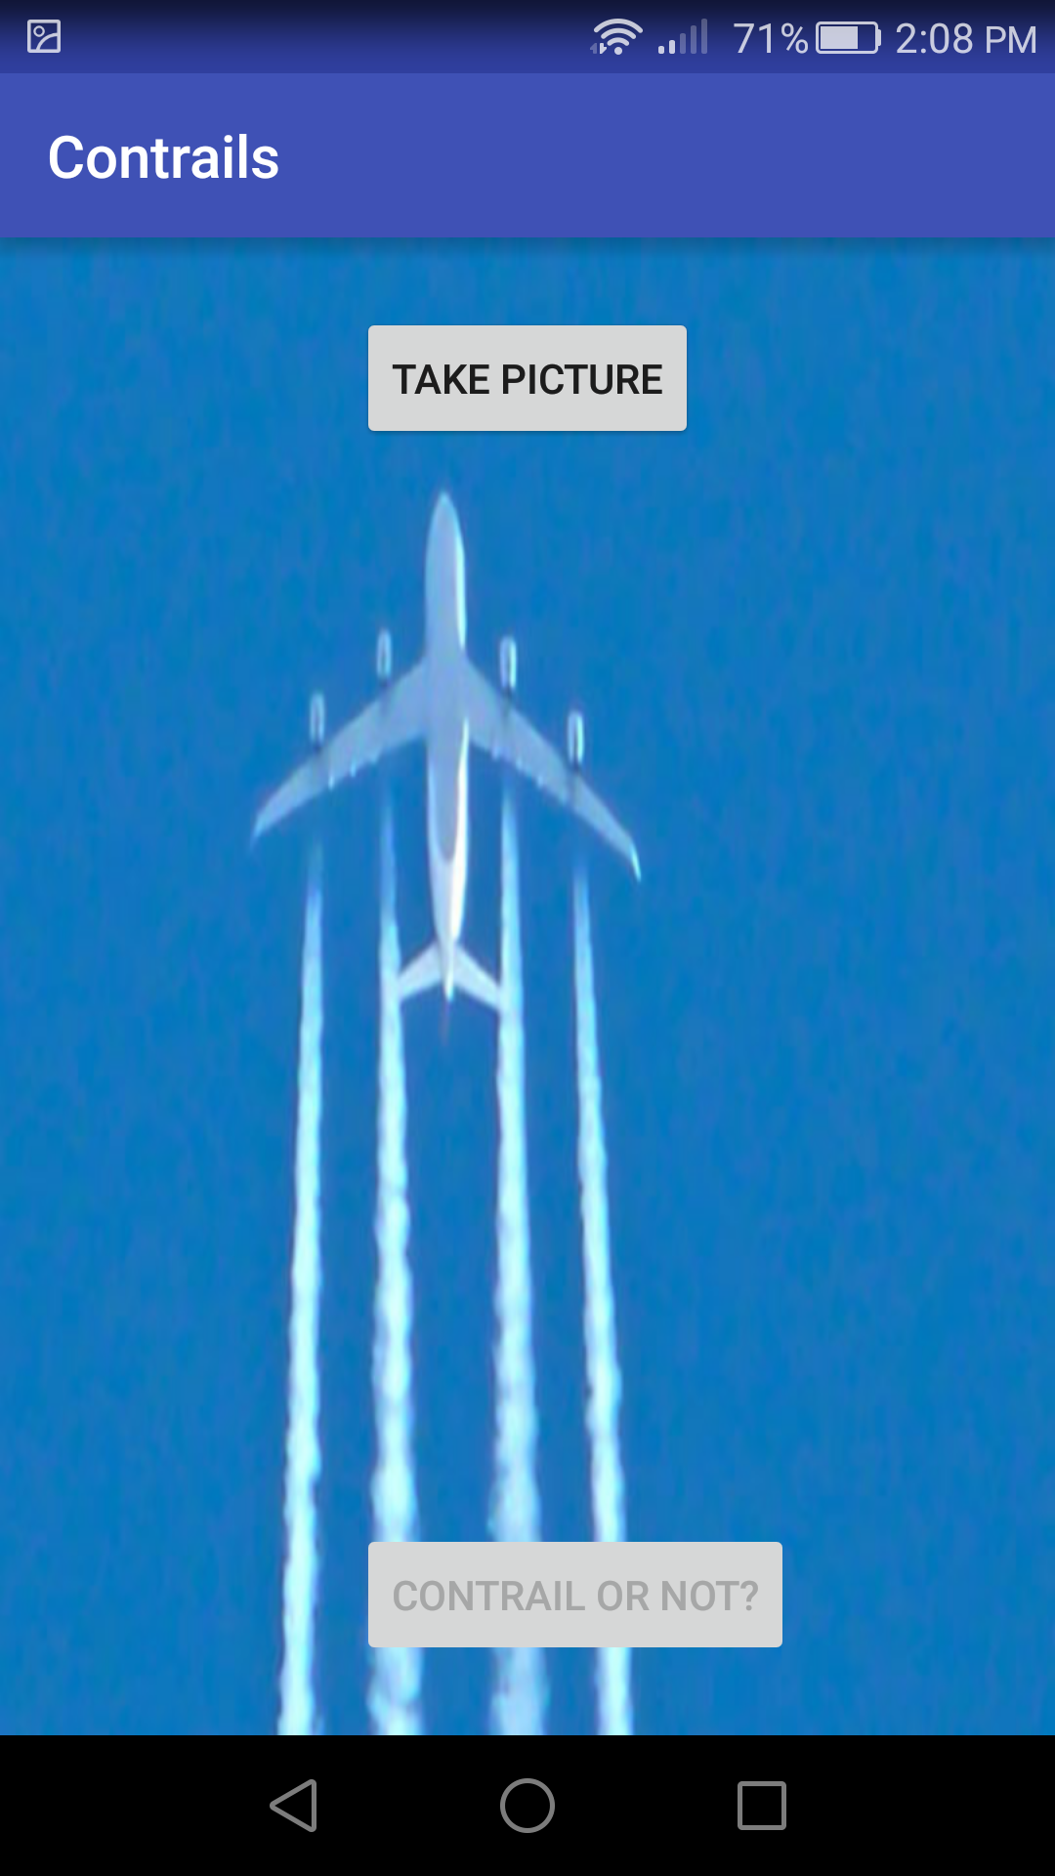

Once the user clicks the button, the phone's native camera is launched which allows the user to take a picture and return back to the main screen.

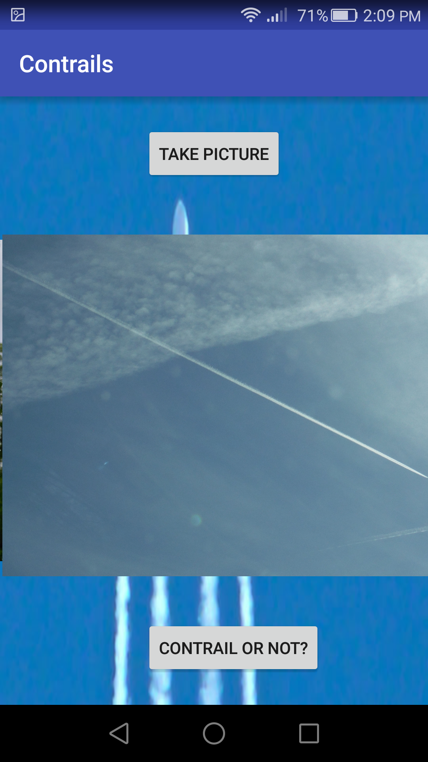

Once the user does that, the button to determine whether the cloud is a contrail or not is enabled. Clicking on that button runs the algorigthm that processes the image and determines whether or not the clould is a contrail.

